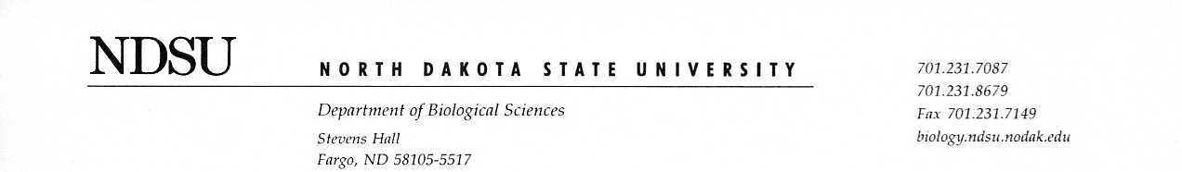
04/09/2021

Dear Editor,

We are grateful for your consideration of our manuscript entitled, “The timing of snowmelt and amount of winter precipitation have limited influence on flowering phenology in a tallgrass prairie.”
In this original work we build a structural equation model to investigate the relationships between winter precipitation, temperature, and flowering phenology using a long-term historical data set. Given the predicted increase in temperature and precipitation in the Midwest, we believe examining the potential consequences to prairie species is crucial and of interest to readers of Global Change Biology. Though prior research in alpine and tundra ecosystems have found a strong relationship between winter precipitation and flowering phenology, this is not the case for upper midwestern prairies where temperature drives flowering phenology in most species.
The manuscript includes one table and four figures. Potential reviewers for this manuscript include Elizabeth Wolkovich (wolkovic@mail.ubc.ca), Paul Reed (preed@uoregon.edu), and Heather Kharouba (heather.kharouba@uOttawa.ca). We appreciate your consideration of our manuscript.

Sincerely,

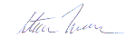

Steve Travers (corresponding author):

Department of Biological Sciences
NDSU Dept. 2715
P.O. Box 6050
Fargo, ND 58108-6050
Steven.travers@ndsu.edu
607-231-9435

